**Sporty Shoes.**

(A**n E-Commerce Website.**)

***(Sprint Work and Project Specification)***



* Version History:

|  |  |  |
| --- | --- | --- |
| **1.** | **Author Name** | **Ankita Asati** |
| **2.** | **Purpose** | Specification of Project and Sprint Work. |
| **3.** | **Date** | 27 Feb 2023 |
| **4.** | **Version** | 1.0 |
| **5.** | **Contact** | [*asati.ankita12@gmail.com*](mailto:asati.ankita12@gmail.com) |

Contents.

1. Introduction. 3
2. Modules in the Project. 3
3. JAVA (Core)Technology Used 4
4. Sprint Wise Work. 5
5. Project GitHub Link. 7
6. Project Code. 7

# Introduction.

Sporty Shoes e-commerce website for managing products in portal and selling shoes to customers online.

In this document you can see the prototype of product operations for both page Admin and Customer interaction.

# Modules in the Project.

* + 1. Registration Page.
    2. Login Page.
    3. User Login.
    4. Change Password.
    5. Dashboard.
    6. Search Products.
    7. Add Cart/View Cart.
    8. View Previous Active Orders.
    9. Pay and Buy Products.
    10. Add Articles.
  1. JAVA (Core)Technology Used:
     1. @Controller: for using class as controller class
     2. @Service: To indicate class as Service
     3. @Repository: To indicate class/interface as Repository to contact with Database.
     4. @Entity: To indicate class as table in Database.
     5. @Autowired: to auto connect between Spring Beans, Services, Repositories.
     6. @PostMapping: to indicate URL links with Servlet post method
     7. @GetMapping: to indicate URL links with Get method in servlet.
     8. @RequestParam and @RequestBody: Get values from webpage.
     9. javax.servlet.http.HttpSession: To manage Sessions with Http protocol.
     10. org.springframework.ui.Model: to send data to view
     11. java.sql.SQLException: To manage Database exceptions
     12. Java.util.regex: to check string patterns like email.
     13. JpaRepository: to get methods for CRUD operations.
     14. jpa.repository.Query (@Query): To write native queries for custom methods for CRUD operations.
     15. ThymeLeaf Template tags in HTML.
     16. @SpringBootApplication: To initialize spring boot.

Technology Used:

## Eclipse IDE

## HTML

## MySQL

## Java Concepts

## Spring Boot DevTools.

## Spring Web

## Spring Data JPA

## ThymeLeaf

# Sprint Wise Work.

## The Sprints have been planned of how the developer can develop with the User interface development and also with the time span of the project was managed within 2 weeks of completion.

## So, each sprint was planned as per the schedule of 4 days for development and one day for testing and the other day for the bug Fixes.

|  |  |  |
| --- | --- | --- |
| **Sr no** | **Sprint Number** | **Sprint Module** |
| **1.** | 1 | 1. Initialized the project, made it Spring boot starter project and added dependencies: MySQL Connector, Hibernate libraries. 2. Setting MySQL database and entities relationship. 3. Configured hibernate and mapped   classes as entities. |
| **2.** | 2 | 1. Planned the structure of the website and navigation across it. 2. Made the controller files. 3. Made a Header and footer jsp pages to include it across every   page. |
| **3.** | 3 | a. Made the customer Login and Registration page.  Admin Login: which is authorised according to data in the database. Change Password: Admin needs to enter the old password to authorise.  Manage Products: Add, Delete, Update Products.  Manage Customers: View, Delete and Search Customers.  Manage Purchases/Orders: View,  Delete and Search Orders. |

|  |  |  |
| --- | --- | --- |
|  |  | b. Modified the navigation with the help of buttons and added the navigation to the home page in the Header Tag. |
| **4.** | 4 | c. Testing of the codes and bug fixes. |

# Project GitHub Link.

|  |  |
| --- | --- |
| **Repository Name.** | SportyShoes(1.0). |
| **GitHub Link.** | https://github.com/ankitaasati/SportyShoes.git |

# Project Code.

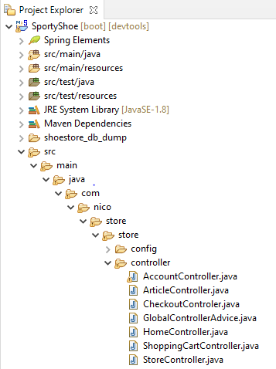

1.***Folder Structure:***

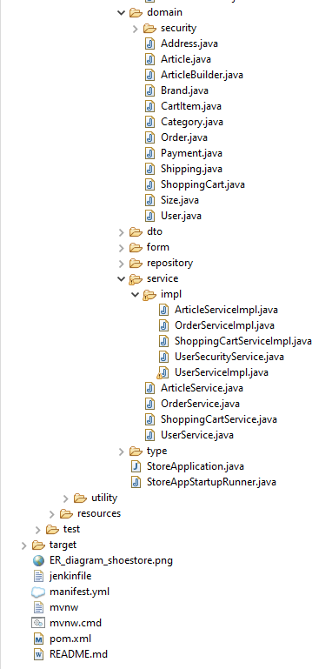

1. ***Controller.***

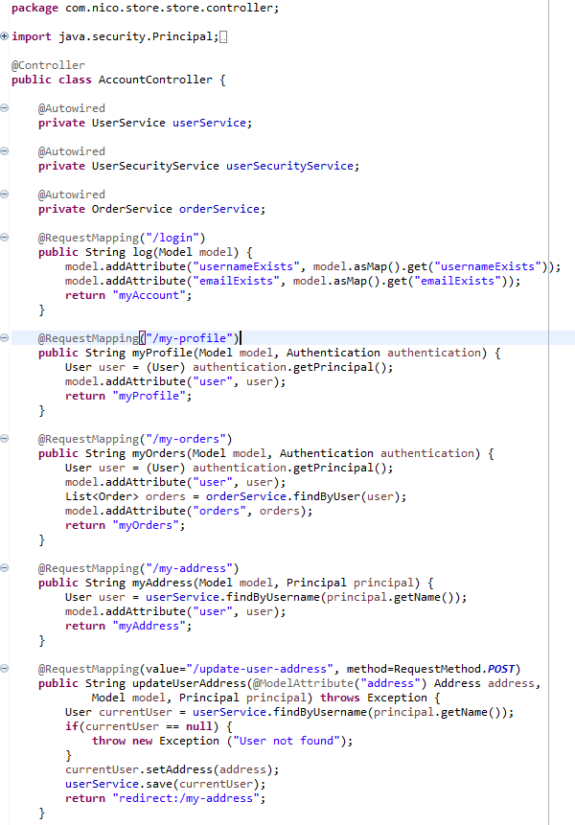

a. AccountController.java

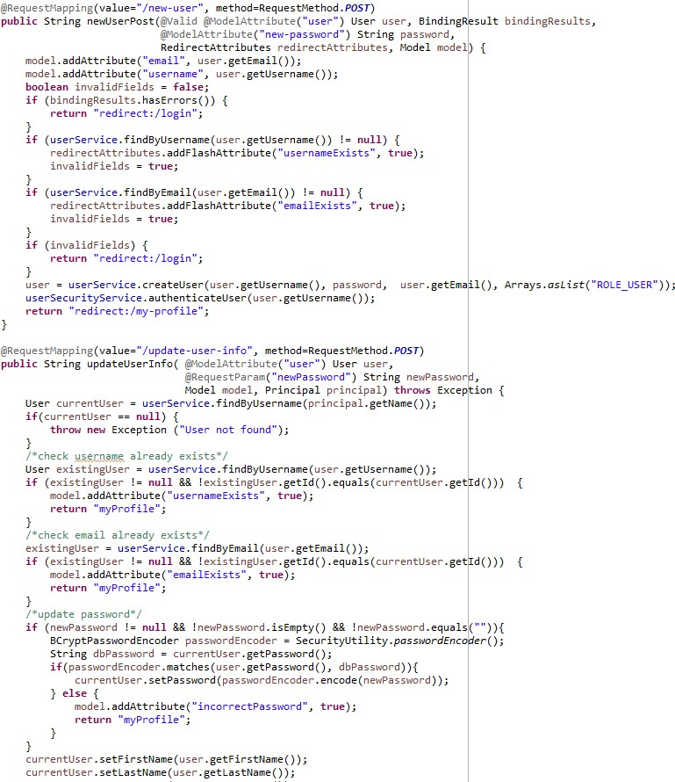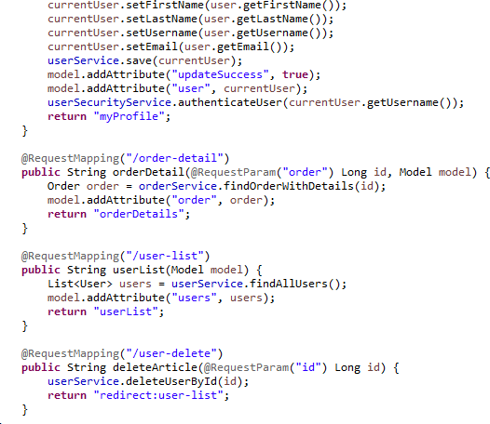

b.ArticleController.java

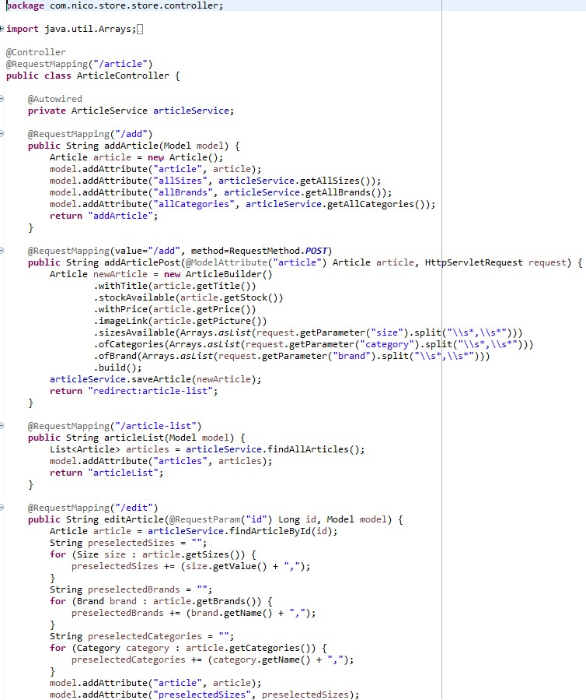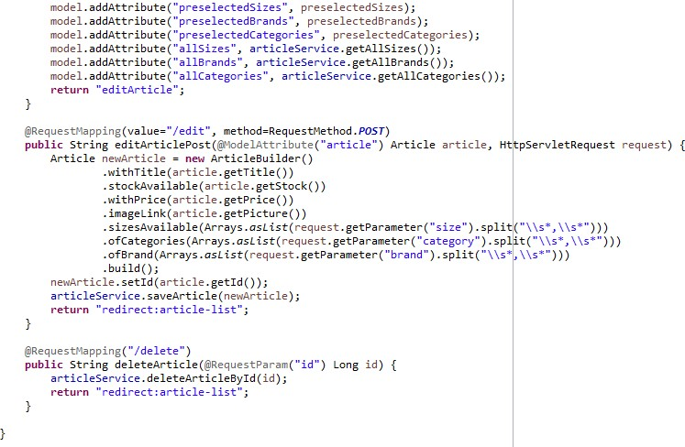

c.Checkout Controler.java.

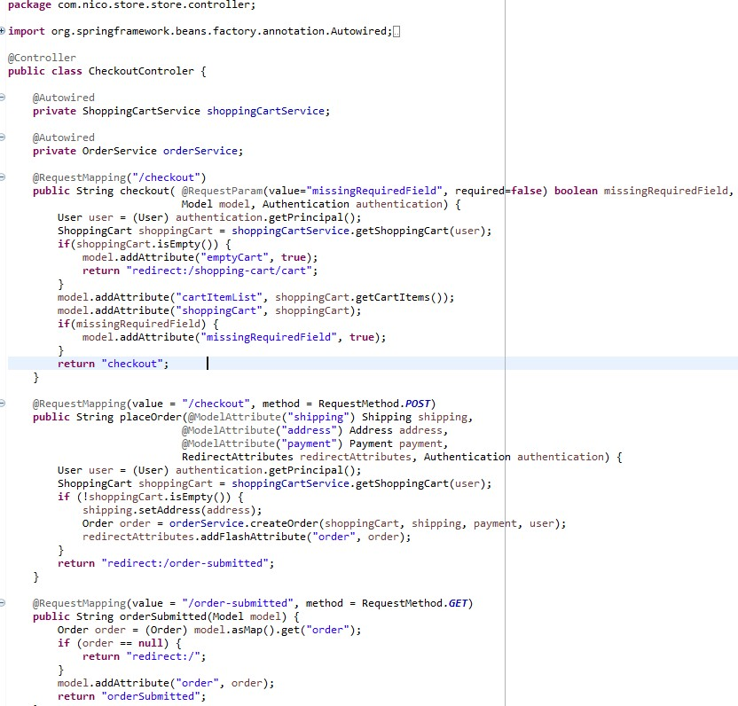

d.GlobalControllerAdvice.java

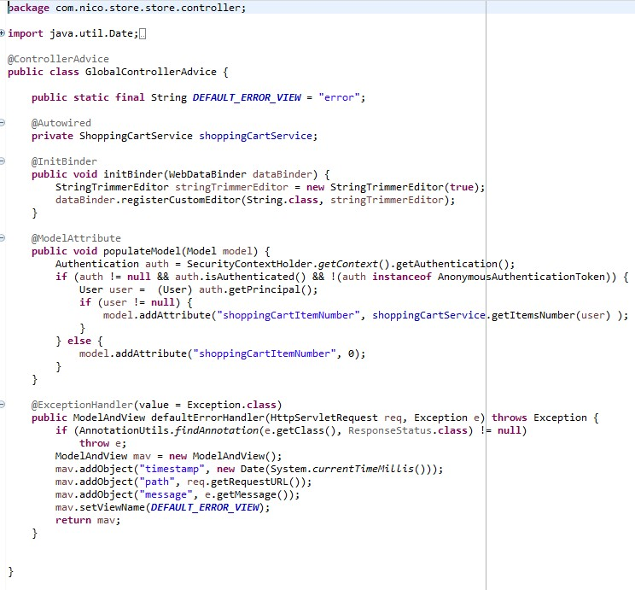

e. HomeController.java

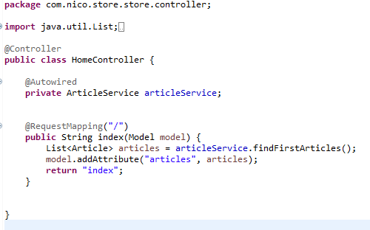

f.ShoppingCartController.java

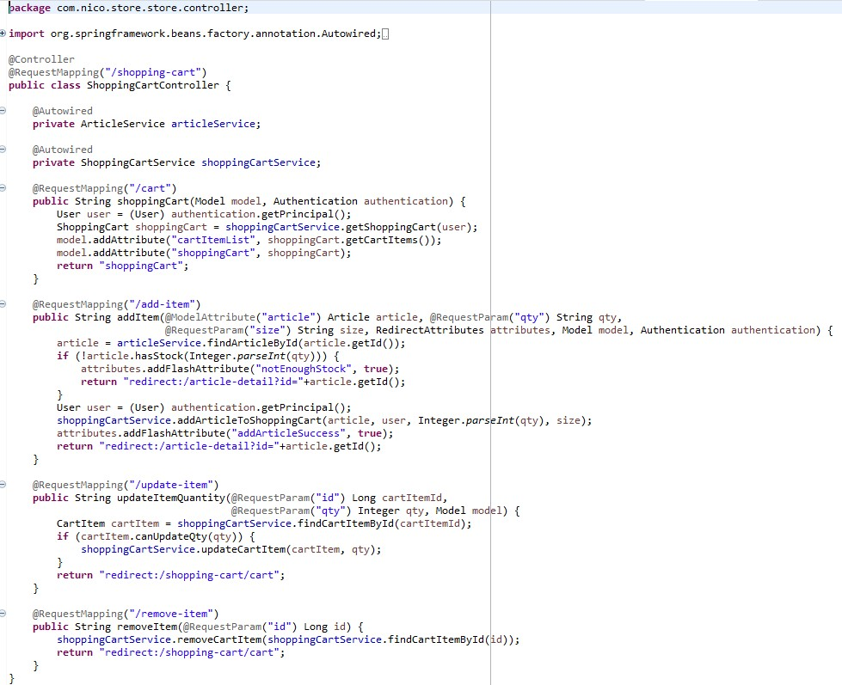

g.StoreController.java

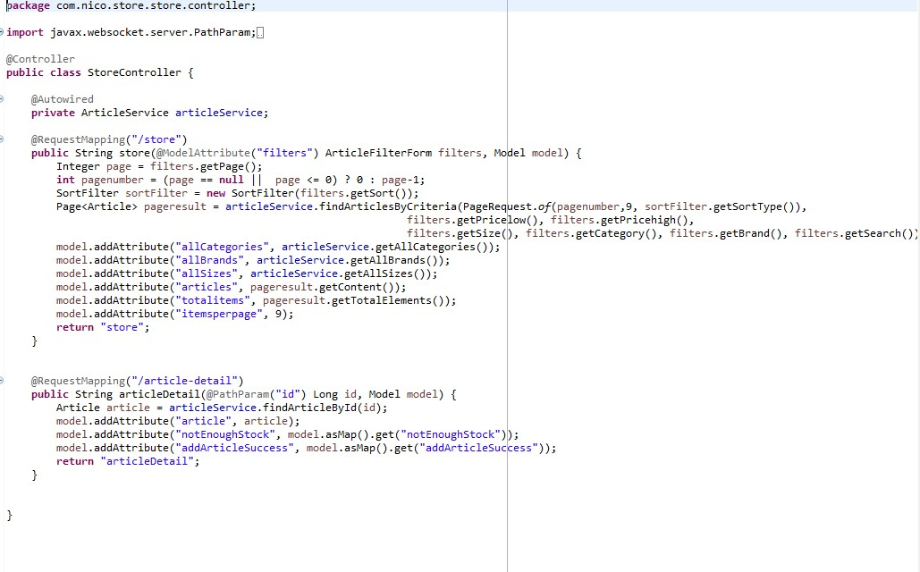

…………………Thankyou………………….